# **CTF Challenge: Finding Location - Using IP Geolocation**

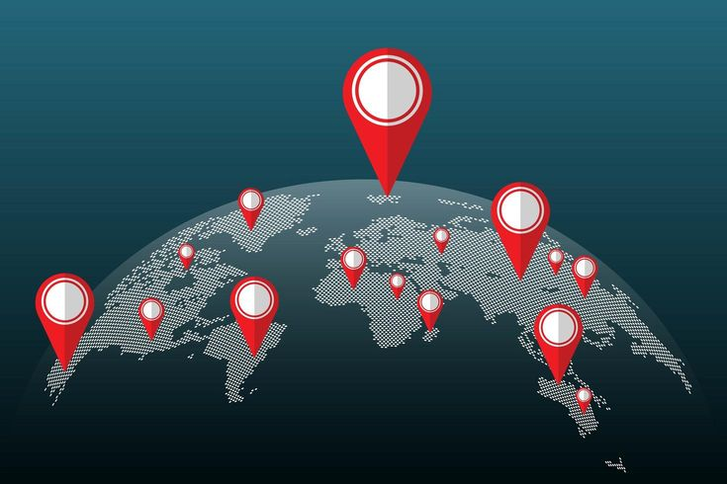

# **1. Introduction**

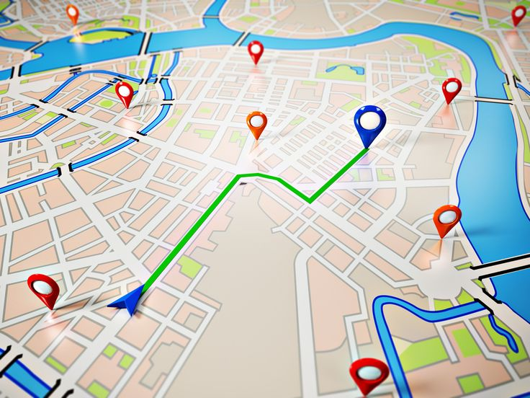

IP Geolocation services provide information about the geographic location and other relevant data associated with an IP address. This challenge will introduce you to using an IP Geolocation service to gather information about a specific IP address.

# **2. Tools and Requirements**

Access to the internet and an IP Geolocation service

# **3. Scenario**



You are an ethical hacker tasked with gathering information about a specific IP address using an IP Geolocation service. Your job is to determine the geographical location of the IP address and identify one relevant detail associated with it.

# **4. Process to follow while performing CTF**

Step 1: Go to your Browser and Visit the link: [**https://ipgeolocation.io/**](https://ipgeolocation.io/)

Step 2: IP Lookup: Enter the IP address **149.154.167.99** in the service's search or lookup tool.

Step 3: Click on view more option.

Step 4: Solve the CTF.

# **5. Let’s Begin the Challenge**

Questions

**Flag 1: What is the Country name of given IP Address?**

Answer: Netherlands

**Flag 2: What is the AS Number of the Given IP Address?**

Answer: AS62041

**Flag 3: In which city the Ip is located?**

Answer: Amsterdam

**Flag 4: What is the calling code of the given IP Address?**

Answer: +31

**Hint**

